A SKIROC2-based prototype electronics system for Silicon PIN array

MA Si-yuan (马思源)1,2, LIU Shu-bin (刘树彬)1,2*, LIU Hao(刘豪) 1,2, FANG Zi- hang(方子航)1,2, LI Cheng(李诚)1,2, FENG Chang-qing(封常青)1,2, AN Qi(安琪)1,2

*1State Key Laboratory of Particle Detection and Electronics, University of Science and Technology of China, Hefei, 230026, China*

*2Department of Modern Physics, University of Science and Technology of China, Hefei, 230026, China*

*E-mail: liushb@ustc.edu.cn*

**Abstract:**

A prototype electronics system, based on the SKIROC2 Application-Specific Integrated Circuit (ASIC), for silicon PIN (Si-PIN) array has been developed. The system consists of two kinds of electronics modules: the Front-End Board (FEB) module and the Data Interface (DIF) module. The FEB, which carries the SKIROC2 ASIC and the Si-PIN diodes array, is in charge of particle detection and analog-to-digital signal conversion, and the DIF is designed to control the FEB and to transfer data to PC via a USB bus. The equivalent noise level of all the 64 channels are below 0.4 fC, while most of them are below 0.2 fC. The dynamic range is up to +3000 fC with an Integral Non-Linearity (INL) of 0.2 %, and the gain non-uniformity is better than 5 %. A type of Si-PIN diode component named S5980 from HAMAMATSU is applied for the system to assess its performance. Tests with a radioactive source (241Am) and cosmic ray have been carried out. The energy resolution with 59 keV X-rays from 241Am is about 13.3 % (in RMS), while the Signal-to-Noise Ratio (SNR) reaches about 10.9 for Minimum Ionizing Particles (MIPs). The details of the system design, together with the test results, are presented in this paper.

**Key words：**SKIROC2, Silicon PIN diode, Front-end electronics, Readout system.

# Introduction

Silicon PIN (Si-PIN) diode, which has advantage of high energy resolution and high linearity, has been widely used in particle physics experiments, such as the XXX of CALorimetric Electron Telescope (CALET) and the XXX of International Linear Collider (ILC) prototype1 2. The next generation experiments, such as the Circular Electron Positron Collider (CEPC) 3 and the ILC, demand finer granularity for their detectors to achieve higher energy resolution and more accurate particle identification capability. This trend results in large amount of Si-PIN diode arrays, leading to a requirement for the electronics system with features of higher integration and lower power consumption than the tradition ones4.

The SKIROC2 (Silicon Kalorimeter Integrated ReadOut Chip 2), which is an ASIC developed by the CALICE collaboration for the Si-PIN signal readout5, integrates 64 channels on one chip and has the feature of low noise and large dynamic range. In this paper, a prototype multi-channel electronics system, based on SKIROC2 ASIC, is designed and implemented, partly as the pre-research of the Si-W (Silicon-Tungsten) electromagnetic calorimeter for CEPC.

# Design and implementation of the system

Shown in Fig. 1 is the block diagram of the readout electronics, which is divided into two parts so that it has the potentiality for expansion of more readout channels by only changing the Front-End Board (FEB). The FEB, which carries a Si-PIN diode array and an ASIC of SKIROC2 on it, provide high voltage for the Si-PIN diodes and process the signals as well. The FEB is configured by a Data InterFace board (DIF) and sends data to the DIF, which then transfers data to PC via USB interface after packing process.



Fig. 1 Block diagram of the electronics system, which mainly consists of the FEB and the DIF.

## SKIROC2 ASIC

Fig. 2 presents the schematic illustration of one channel of SKIROC2, on which 64 same channels are integrated. Each channel is composed of a Charge-Sensitive Amplifier (CSA), two slow shapers with different gains, one fast shaper with a discriminator, a time-to-digital convertor (TDC) for time measurement, three Switched Capacitor Arrays (SCA) of 15 depth to store analog signal and an Analog-to-Digital (ADC) to convert signal from analog to digital.

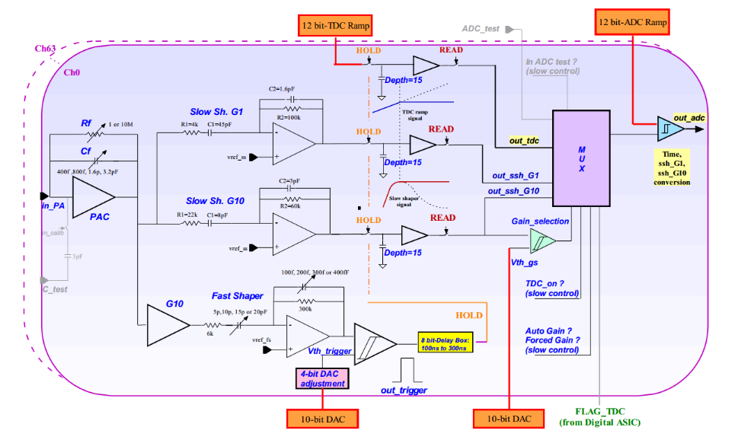

Fig. 2 The schematic illustration of the analog part of SKIROC2 (one channel).

The input signal passes through the CSA with the variable gain set by switchable Feedback Capacitance (Cf) array. And the output of CSA is fed to a fast shaper and a slow shaper, for trigger and precise measurement respectively. By comparing the fast shaper’s output with a threshold set by an 10-bit on-chip Digital-to-Analog Convertor (DAC), the discriminator generates a trigger signal to hold the voltages at two slow shaper outputs, which are optimized for low-noise charge measurement, on the SCAs. The signals on the SCAs are read out and converted by a 12-bit Wilkinson ADC, with a bunch ID tagged on a 10 MHz clock, then saved in the on-chip memory.

Benefitting from the two different-gain slow shapers and the adjustable-gain CSA, the SKIROC2 has a wide dynamic range, ensuring a linear response for equivalent input charge up to +3000 fC, with a noise level as low as 0.2 fC in RMS. The peak time of the chip is tuneable from 50 ns to 200 ns to suit different signals, and the power consumption is only about 6 mW per channel. In addition, the SKIROC2 can be configured to be either self-triggered or external-triggered, and this satisfies different experiment conditions. With these features that meet the readout requirements of Si-PIN diode arrays in many kinds of experiments, the SKIROC2 is chosen as the front-end readout chip of the system.

## Front-end Board

The FEB, which accommodates one SKIROC2 chip and 64 Si-PIN compoments, is divided into two parts: the Detector-Part and the ASIC-Part, so that it is convenient to test different kinds of Si-PIN diodes without redesigning the ASIC-Part. The ASIC-part is mainly designed to make the SKIROC2 functions well. PCB connectors (ERNI-154744) are used both for gathering detectors’ outputs from Detector-Part to SKIROC2 ASIC, and for connecting the ASIC with DIF.

In addition, there are two kinds of control signals named by their speed: fast control and slow control. The fast control, which include SKIROC2’s clock, trigger and reset and SCA validation signals, are sent to the control center of SKIROC2 directly through Low Voltage Differential Signal pairs (LVDS). While the slow control, on the other hand, is in a daisy chain cascade and configures the 616-bit registers on the chip, which store some configurations such as the feedback capacitance of the CSA and the trigger mode. The digitalized output data of the SKIROC2 are sent to the DIF through the Open Collector (OC) gate. Considering the OC gate and the daisy chain cascade, it is very convenient to expand the FEB for more ASICs without changing the definition of the connector to DIF.



Fig. 3 Block diagram of Front-end Board, which consists of Detector part and ASIC part.

The Detector-Part carries a Si-PIN diodes array and supplies them. At present, a type of Si-PIN diode named S5980 from HAMAMATSU is adopted to verify the performance of the system7. The active area of the diode is 5 × 5 mm2, the thickness of depletion layer is 80µm, and the dark current is only 100 pA while the thermal capacitance is as small as 10 pF. Since the output noise of the diode is sensitive to the High Voltage (HV) ripple, the cathode of the diode is connected to a HV of 13 V, supported by a well-designed Low-DropOut regulator (LDO, TPS7A4700 from Texax Instruments company) with high power supply ripple rejection rate. The anode of the diode is directly connected to SKIROC2’s input, which supplies a reference voltage about 1 V to ensure the correct working status of the Si-PIN diode.

## Data Interface

The DIF consists of four main parts: the FPGA part, the connector part, the power supply part and the interface part. The FPGA part is mainly composed of an FPGA (ARTIX7, Xilinx) and a PROM (N25Q128). The function of the FPGA is to implement the required logic to control the FEB and to communicate with the PC. The connector part to FEB is via two ERNI-154744 connectors, as mentioned before. The supply part is implemented with a DC input (5V) from outside and several LDO regulators, generating supply for the DIF and the FEB. The interface part is in charge of communicating with PC through a mini-USB port, realized by a USB chip CY7C68013. In addition, an optical transceiver interface is remained for compatibility with other readout device.



Fig. 4 Block diagram of logic implemented in the FPGA

The logic diagram of the FPGA is presented in Fig. 4. The acquisition module controls the ASIC to work in normal mode and process the data from SKIROC2, which are first stored in the FIFO, then packed and finally transferred to PC. The trigger module is in charge of generating a trigger when the external trigger is in need, while normally the chip is self-triggered. The calibration module and S-curve module are used to control the ASIC during calibration or testing, which is elaborated below. The optical module and USB module are responsible for receiving commands and transmitting data to the server.

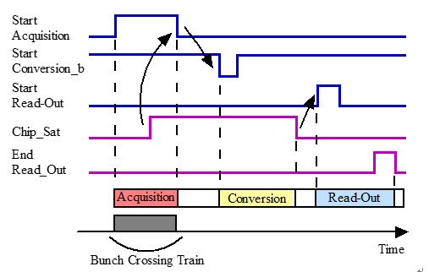

Fig. 5 Global timing control of data acquisition for SKIROC2

The timing control sequence of the main signals during the normal acquisition progress is shown in Fig. 5. This global sequencing is made around three signals from FPGA on the DIF: StartAcquisition, StartConversionb and StartReadout. In response to the three signals, the SKIROC2 answers with two signals: Chip_Sat and End_Readout. The acquisition is composed of 3 phases: Acquisition, Convertion and Readout. The acquisition phase starts when the StartAcquisition has a rising edge and ends when this signal falls. During the acquisition phase, the SKIROC2 outputs a rising edge of Chip_Sat signal, informing that the 15-depth SCA array is full. By giving a falling edge of StartConvsionb, the SKIROC2 begins to convert signals from analog to digital. When the conversion is finished, the Chip_Sat signal falls and a rising of StartReadout signal is sent from DIF to SKIROC2, starting the readout phase. The End_Readout rises when the transmission is over. It is worth noting that the End_Readout signal is in daisy chain that the following SKIROC2’s readout phase could be started by this signal, if there are more than one ASIC.

The prototype electronics system has been implemented and the picture of the FEB and the DIF is shown in Fig. 6.



Fig. 6 The photograph of FEB and DIF.

# Characterization

We have carried out a number of characterizations to assess the performance of the system. The results of basic output, baseline noise and calibration of SKIROC2, trigger efficiency, X-ray test and cosmic test are presented and discussed below.

## Basic output of SKIROC2

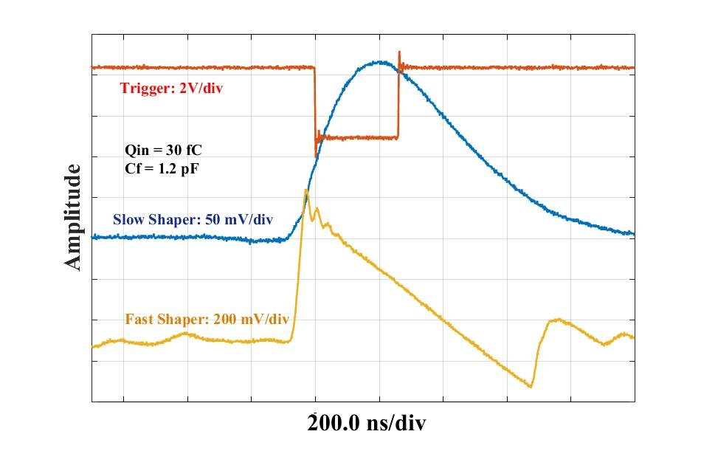

Fig. 7 The typical outputs of the fast shaper, slow shaper and trigger from single channel.

Although the SKIROC2 is designed to send out digitalized data, an analog probe is remained to observe the outputs of analog part for debugging. The basic outputs, such as slow shaper, fast shaper and trigger, of every channel was observed to make sure that all channels are in correct status. A typical waveform of the fast shaper, slow shaper and trigger from single channel is shown in Fig. 7. From the waveform, the fast shaper is about 200 ns ahead of the peaking time, so that a trigger from the discriminator next to the fast shaper could be used to hold the peak of the slow shaper output.

## Baseline and noise

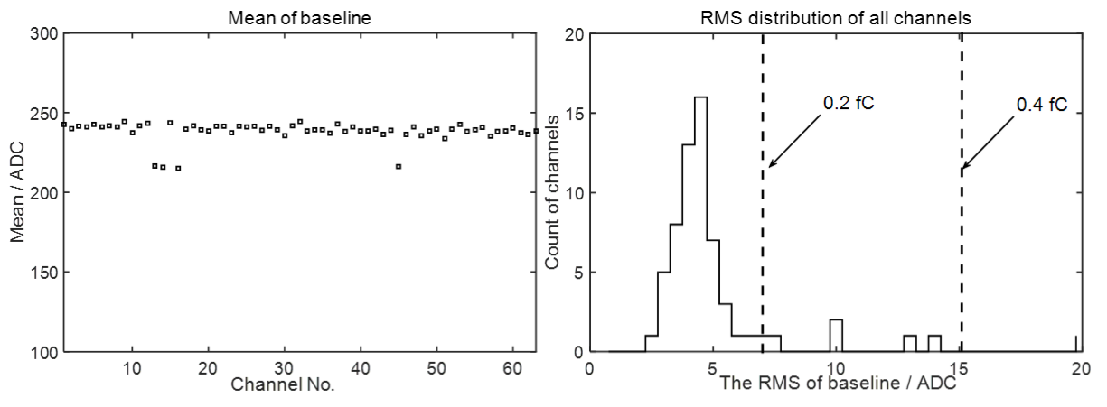

Fig. 8 The baseline and noise distribution of all 64 channels.

In order to evaluate the noise level of the system, the external trigger function of SKIROC2 was used to get the pedestal of the system without detectors. Since the SKIROC2 requires 4 ms for conversion phase and readout phase, triggers in a fixed time interval of 10 ms were generated by the DIF, controlling the acquisition of the baseline. The chip held the baselines of all 64 channels and converted them to digital when triggered. Fig. 8 shows the average of baselines and sigma of noise from all channels. The results showed that all channels exhibited reasonable baseline and noise results, and most channels demonstrated a noise level lower than 0.2 fC equivalent input charge.

## Calibration

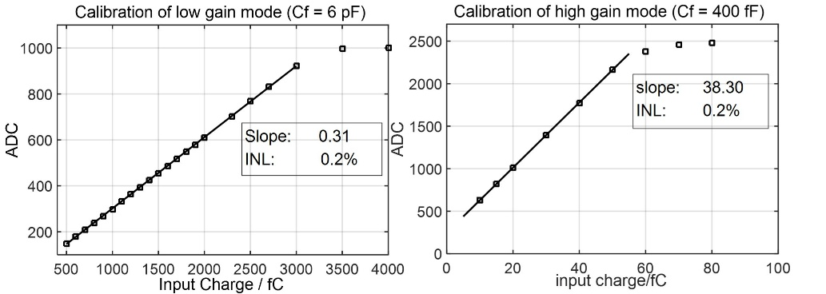

Fig. 9 The linear fit results of two gain modes of SKIROC2.

The calibration assessment was carried out to obtain the linearity and dynamic range of the SKIROC2 chip. By taking advantage of the SKIROC2’s 3 pF calibration capacitors on each channel, the self-calibration was conducted by the procedure elaborated below. A waveform generator with attenuator was used to generate step pulses with different amplitudes. When the step pulses were applied to the on-chip capacitor, a certain amount of charge, which covered the full range, was injected into every channel of SKIROC2 from the test pulse input for performance assessment. The SKIROC2 chip has many operation modes by tuning the Cf array. The measurement was carried out with the highest gain mode (Cf = 400 fF) and lowest gain mode (Cf = 6 pF). The gain uniformity between different channels was better than 5% and the typical linear curves of output ADC code versus input charge, of the two modes, are shown in Fig. 9. Fig. 9 shows that the linear range of the highest gain mode and the lowest gain mode were 50 fC and 3 pC, respectively. The Integral non-linearities (INL) of both modes reached up to 0.2%.

## Trigger efficiency



Fig. 10 The trigger efficiency for two channels as a function of threshold setting for an input charge of 2 fC.

The trigger efficiency was obtained from an “S-curve” as presented in Fig. 10. The trigger threshold was set by two digital-to-analog conversion (DAC) settings on chip: a global threshold with a 10-bit DAC and channel by channel adjustment with a 4-bit DAC. To measure the trigger efficiency, a fixed amount of charge was introduced from the test pulse input. If the fast shaper pulse exceeds the threshold, the SKIROC2 chip generates a trigger signal for counting. The S-curve was obtained by varying the trigger threshold 10-bit DAC and recording the efficiency at each DAC code. The curve was fitted by a complementary error function, the centre value corresponds to the charge threshold and the sigma parameter represents the noise-induced width. The results of the curve is closed to the previous work finished by T. Suehara8. The 4-bit DAC adjustment for every channel should help to get a better threshold uniformity, but this function did not work properly in SKIROC2 due to a detected bug, which has been fixed in a newer version of SKIROC2a.

## X-ray test and Cosmic ray test



Fig. 11 The spectrum of the X-ray of 241Am (left) and the pedestal and MIP distribution of cosmic ray (right).

Several S5980 Si-PIN diodes were soldered on the FEB to test the performance of the system. A joint test with an X-ray source of 241Am and a test with cosmic ray were carried out. During both tests, outputs of the diodes were directly sent to the SKIROC2, which was set to work in the highest gain mode. The spectrum of 59 keV X-ray is shown in the left one of the Fig. 11. It can be observed that the shape is not a standard Gaussian, which is because in some cases the photoelectric conversion occurs before the depletion layer and losses some energy. According to the calibration results, the equivalent input charge was 2.89 fC and the resolution was 13.3% (in RMS). The right one of the Fig. 11 is the result of cosmic ray test from a single channel. The SKIROC2’s trigger threshold was set at 0.5 Minimum Ionizing Particle (MIP, with about 5 σ separation of the noise) to get signal from cosmic ray. In addition, there was a random external trigger to get the pedestal noise. The spectrum of the cosmic ray was Landau fitted and the pedestal was Gaussian fitted. The results of the fits showed that the Signal-to-Noise Ratio (SNR) for MIP was 10.9, which was closed to the test results of other electronics using SKIROC2 ASIC9. These tests show that the system has enough resolution to identify small signals such as X-ray and MIP.

# Conclusions

In this paper, a SKIROC2-based prototype electronics system for Si-PIN array, as well as the performance test, have been presented. The system, which consists of FEB module and DIF module, has features of high integration, low noise and high dynamic range. Considering the daisy chain structure of the SKIROC2, it is easy to expand the FEB for more ASICs without changing the interface protocol. The SKIROC2, as well as the design concept of the electronics system can be applied for the preliminary prototype Si-W ECAL of CEPC.

Acknowledgments

The authors would like to thank Mr. Stephane Callier from CALICE collaboration for his help in our system design progress. We also appreciate the discussion, during the design progress, with Mr. Yunlong Zhang from University of Science and Technology of China. This work was supported by National Natural Science Foundation of China (Grant No. 11635007).

1. S. Marrocchesi P, Adriani O, Avanzini C, et al. A silicon array for cosmic-ray composition measurements in CALET. Journal of the Physical Society of Japan, 2009, 78(Suppl. A): 181-183.
2. T. Behnke et al., The International Linear Collider Technical Design Report - Volume 4: Detectors, [arXiv:1306.6329].
3. CEPC-SPPC Study Group, CEPC-SPPC preliminary conceptual design report: Physics and detector, Tech. Rep. IHEP-CEPC-DR-2015-01, IHEP-TH-2015-01, IHEP-EP-2015-01, 2015.
4. CALICE collaboration, J. Repond et al., Design and Electronics Commissioning of the Physics Prototype of a Si-W Electromagnetic Calorimeter for the International Linear Collider, 2008 JINST 3 P08001 [arXiv:0805.4833].
5. S. Callier, F. Dulucq, C. de La Taille, G. Martin-Chassard and N. Seguin-Moreau, SKIROC2, front end chip designed to readout the Electromagnetic CALorimeter at the ILC, 2011 JINST 6 C12040.
6. ERNI Homepage, <http://www.erni.com/cn/produkte/show/product/154744/>, last accessed 2018/3/26.
7. HAMAMATSU Homepage, <http://www.hamamatsu.com/resources/pdf/ssd/si_pd_kspd0001e.pdf>, last accessed 2018/3/26
8. T. Suehara et al., Performance study of SKIROC2/A ASIC for ILD Si-W ECAL, 2018 JINST 13(03) C03015
9. CALICE collaboration, Response of the CALICE Si-W ECAL Physics Prototype to electrons, J. Phys. Conf. Ser. 160(2009) 012065 [arXiv: 0811.2354].